**PIZZA SALES SQL QUERIES**

**A. KPI’s**

**1. Total Revenue:**

**SELECT**

**SUM(total_price) AS total_revenue**

**FROM**

**pizza_sales;**

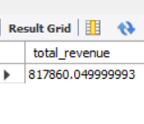

**2. Average Order Value**

**SELECT**

**(SUM(total_price) / COUNT(DISTINCT order_id)) AS avg_order_value**

**FROM**

**pizza_sales;**

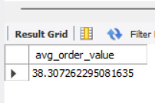

**3. Total Pizzas Sold**

**SELECT**

**SUM(quantity) AS total_pizza_sold**

**FROM**

**pizza_sales;**

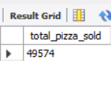

**4. Total Orders**

**SELECT**

**COUNT(DISTINCT order_id) AS total_orders**

**FROM**

**pizza_sales;**

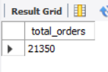

**5. Average Pizzas Per Order**

**SELECT**

**ROUND((SUM(quantity) / COUNT(DISTINCT order_id)),**

**2) AS avg_pizzas_per_order**

**FROM**

**pizza_sales;**

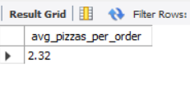

**B. Daily Trend for Total Orders**

**SELECT**

**DATE_FORMAT(order_date, '%a') AS order_day,**

**COUNT(DISTINCT order_id) AS total_orders**

**FROM**

**pizza_sales**

**GROUP BY order_day;**

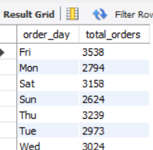

**C. Monthly Trend for Orders**

**SELECT**

**DATE_FORMAT(order_date, '%M') AS Month_Name,**

**COUNT(DISTINCT order_id) AS total_orders**

**FROM**

**pizza_sales**

**GROUP BY Month_Name;**

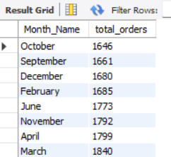

**D. % of Sales by Pizza Category**

**SELECT**

**pizza_category,**

**ROUND(SUM(total_price), 2) AS total_revenue,**

**ROUND(SUM(total_price) * 100 / (SELECT**

**SUM(total_price)**

**FROM**

**pizza_sales),**

**2) AS PCT**

**FROM**

**pizza_sales**

**GROUP BY pizza_category;**

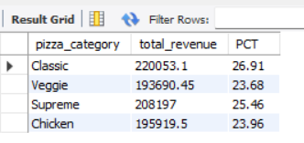

**E. % of Sales by Pizza Size**

**SELECT**

**pizza_size,**

**ROUND(SUM(total_price), 2) AS total_revenue,**

**ROUND(SUM(total_price) * 100 / (SELECT**

**SUM(total_price)**

**FROM**

**pizza_sales),**

**2) AS PCT**

**FROM**

**pizza_sales**

**GROUP BY pizza_size;**

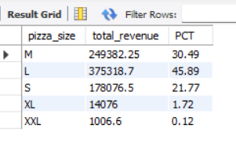

**F. Total Pizzas Sold by Pizza Category**

**SELECT**

**pizza_category, SUM(quantity) AS total_qty_sold**

**FROM**

**pizza_sales**

**GROUP BY pizza_category**

**ORDER BY total_qty_sold DESC;**

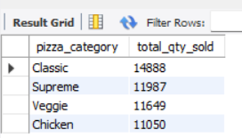

**G. Top 5 Pizzas by Revenue**

**SELECT**

**pizza_name, SUM(total_price) AS total_revenue**

**FROM**

**pizza_sales**

**GROUP BY pizza_name**

**ORDER BY total_revenue DESC**

**LIMIT 5;**

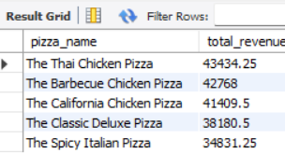

**H. Bottom 5 Pizzas by Revenue**

**SELECT**

**pizza_name, ROUND(SUM(total_price), 2) AS total_revenue**

**FROM**

**pizza_sales**

**GROUP BY pizza_name**

**ORDER BY total_revenue**

**LIMIT 5;**

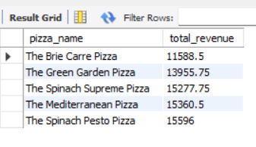

**I. Top 5 Pizzas by Quantity**

**SELECT**

**pizza_name, SUM(quantity) AS total_pizza_sold**

**FROM**

**pizza_sales**

**GROUP BY pizza_name**

**ORDER BY total_pizza_sold DESC**

**LIMIT 5;**

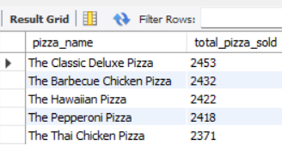

**J. Bottom 5 Pizzas by Quantity**

**SELECT**

**pizza_name, SUM(quantity) AS total_pizza_sold**

**FROM**

**pizza_sales**

**GROUP BY pizza_name**

**ORDER BY total_pizza_sold**

**LIMIT 5;**

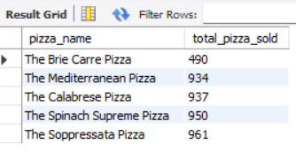

**K. Top 5 Pizzas by Total Orders**

**SELECT**

**pizza_name, count(distinct order_id ) AS total_orders**

**FROM**

**pizza_sales**

**GROUP BY pizza_name**

**ORDER BY total_orders DESC**

**LIMIT 5;**

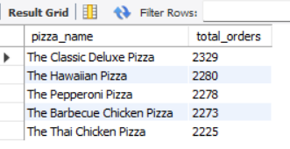

**L. Borrom 5 Pizzas by Total Orders**

**SELECT**

**pizza_name, COUNT(DISTINCT order_id) AS total_orders**

**FROM**

**pizza_sales**

**GROUP BY pizza_name**

**ORDER BY total_orders**

**LIMIT 5;**

